CSA 283: Final

Name: ______________________________________ Section: _____ _____

Please write legibly. Ask questions if something is unclear. Write down any assumptions you make.

Some useful formulas:
d_{trans} = L/R d_{prop} = d/s

- Consider the network diagram shown in the supplemental handout. The diagram depicts the following:

- Four end systems labeled A, B, C, and D
- One switch labeled S1
(Switch interfaces are labeled 1 – 3)
- One 803.11 wireless access point labeled A1
- Four routers labeled R1, R2, R3, and R4
(The interfaces of R2 are labeled 1 – 3)
(Router R1 is performing NAT)

Information held at various nodes is given on the page following the diagram.

In the following questions consider a message being sent from host A to host B and from host A to host C and the segments, packets, and frames that will be generated to carry the message.
- The socket on A that is being used to send messages has a port number of 4500.
- The port number of the socket being used on C to receive the message is 3000.

Use the diagram and tables contained in the supplemental handout to answer the following questions.

    - Would the switch labeled S1 have a MAC address? (2 points)

    - What protocol will A use to determine the IP address of C? (2 points)

    - Does A need the MAC address of R1 in order to send a packet to C? How would it obtain it? (2 points

    - When A is sending a packet to C, will the switch table for S1 be modified? If so how? (4 points)

    - Could both A and B transmit simultaneously without colliding? Why or why not? (2 points)

    - When A is sending a packet to C, will the network interface adapter of B receive the frame that is sent by A to R1? Why or why not? (4 points)

    - When a packet travels from A to C, what will the source and destination physical addresses be in the frame that travels from R1 to R2? (2 points)

Source ____________________________________

Destination ____________________________________

    - When A is sending a packet to C, what will be the source IP address and port number in the packet/segment that travels between A and R1? (4 points)

Source IP ____________________________________

Source Port ____________________________________

    - When A is sending a packet to C, what will be the source IP address and port number in the packet/segment that travels between R1 and R2? (2 points)

    - Based on the forwarding table given for R2, when A is sending a packet to C, will it forward the packet to R3 or R4? (4 points)

    - When A is sending a packet to C, will the frame that is sent from R5 to C be seen by network interface adapter of D? Why or why not? (4 points)

    - If C sends a reply back to A, what will the destination IP address and destination port number be in the packet/segment that travels between C and R5? (4 points)

Destination IP ____________________________________

Destination Port ____________________________________

    - If C sends a reply back to A, what will the destination IP address and destination port number be in the packet/segment that travels between R1 and A? (4 points)

Destination IP ____________________________________

Destination Port ____________________________________

    - If C sends a reply back to A, will the switch table for S1 be modified? If so how? (4 points)

    - Would B use ARP to get the MAC address of A? (4 points)

    - Give the Classless InterDomain Routing (CIDR) notation for the subnets identified by forwarding table of R2. Indicate approximately how many hosts each sub-net could contain. (6 points)

CIDR notation Approx. Number of Hosts

________________________ __________

________________________ __________

________________________ __________

- Each of the following terms pertains to a difficulty that may be encountered in a wireless network. Match each term with the appropriate description by writing the letter for the term next to the description.

- Signal Attenuation
- Signal Interference
- Multipath Propagation
- Hidden Terminal Problem

_________ Multiple arrivals of a given signal at the receiver because the same signal has followed several paths to reach the receiver.

_________ Loss of RF signal strength as the signal travels over a distance and/or passes through obstacles such as walls.

_________ The inability of one wireless node to hear another wireless node due to the presence of an RF energy obstruction between the nodes.

_________ Degradation RF signal quality due to the presence of device such as wireless phone which are transmitting RF signals.

- Host A is sending segments to Host B using the TCP protocol. Host A has calculated the congestion window to be 23,000 bytes. The receive window for Host B to which the host A is sending data is 18,000 bytes. Host A has transmitted 12,000 bytes of data. 7,000 of these bytes have been acknowledged.

    - What is the maximum number of bytes Host A will transmit to Host B at this time? (4 points)

    - Is flow control or congestion control limiting the transmission rate?
(4 points)

- Give definitions for the following terms using one or two sentences. If the term is an acronym, also state what the letters in the acronym stand for and give a definition.

a. Beacon Frame(6 points):

b. CTS (6 points):

c. CSMA/CD (6 points):

d. Dual Stack

e. Conditional GET

f. Overlay Network
- Using node A in Figure 2 as the source, use the link state (LS) algorithm to find the shortest path to all other nodes. Show the members of N, the predecessor of each destination, and the shortest known distance to each destination after the initialization phase of the algorithm and after each loop iteration. (14 points)
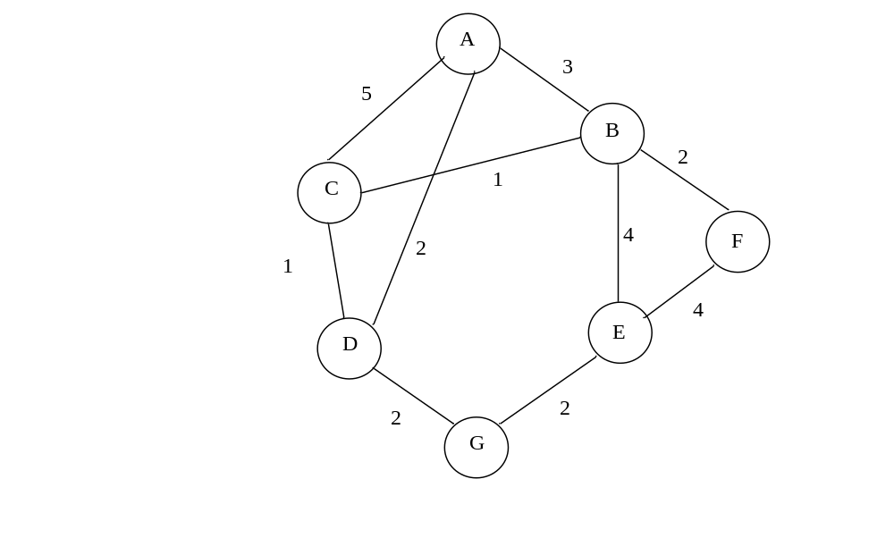
Figure 2: Network Graph

- A block of data for transmission using the TCP protocol has been broken up for transmission into four separate segments. The sequence number of the first segment is 0.The first segment contains 44 bytes of data, the second segment also contains 44 bytes the third segment contains 12 bytes, and the fourth segment again contains 44 bytes. Write the correct sequence number for each segment. (8 points)

TCP Segment Sequence Number
First Segment
Second Segment
Third Segment
Fourth Segment

- Recall that TCP uses cumulative acks. Suppose that segments actually arrive at the receiving end in the following order.

First segment, Third segment, Fourth Segment, Second Segment

    - Give the TCP acknowledgement that will be sent for each segment if the receiver is using a Go-Back-N protocol. (4 points)

_______ First segment

_______ Third segment

_______ Fourth Segment

_______ Second Segment

    - Give the TCP acknowledgement that will be sent for each segment if the receiver is using a Selective-Repeat protocol. (4 points)

_______ First segment

_______ Third segment

_______ Fourth Segment

_______ Second Segment

- Use the constants below to answer the following questions. Show work for partial credit. Indicate the units for each answer. Show times to four decimal places. Assuming processing and queuing delays are negligible.

Bits being transmitted 40,000 bits
Packet Size 1000 bits
Link Bandwidth 30,000 bps
Link Lengths 20,000 M
Propagation Speed 2.8 x 10⁸ Mps

a. Calculate the propagation delay for a single link. (2 points)

b. Calculate the transmission delay for a single packet and a single router.
(2 points)

- Calculate the bit time for this bandwidth. (2 points)

- Assuming there are four links connected by routers and that processing and queuing delays are negligible, calculate the time required for a single packet to travel from A to B at the end of the fourth link. (4 points)
A
B

- Again, assume there are four links connected by routers and that processing and queuing delays are negligible. For pipelined transmission, calculate the time needed for the entire file to reach B at the end of the fourth link. (4 points)

- Consider the following scenario:

A network application running on frodo.nps.edu wants to transmit packets for www.muohio.edu. In the following, assume that all DNS servers (including the local server) use caching and that all DNS caches are minimal information. Assume all queries are handled recursively. DNS server names are as follows:

TLD DNS server, edu: dns.tld.edu
TLD DNS server, org: dns.tld.org
Local DNS server, nps: local.nps.edu
Local DNS server, muohio: local.muohio.edu
Authoritative DNS, muohio: dns.muohio.edu
Authoritative DNS, nps: dns.nps.edu
Root DNS server: dns.root

- Draw arrows labeled with numbers to indicate the order of queries and responses sent before frodo.nps.edu receives the IP address of www.muohio.edu.
(16 points)
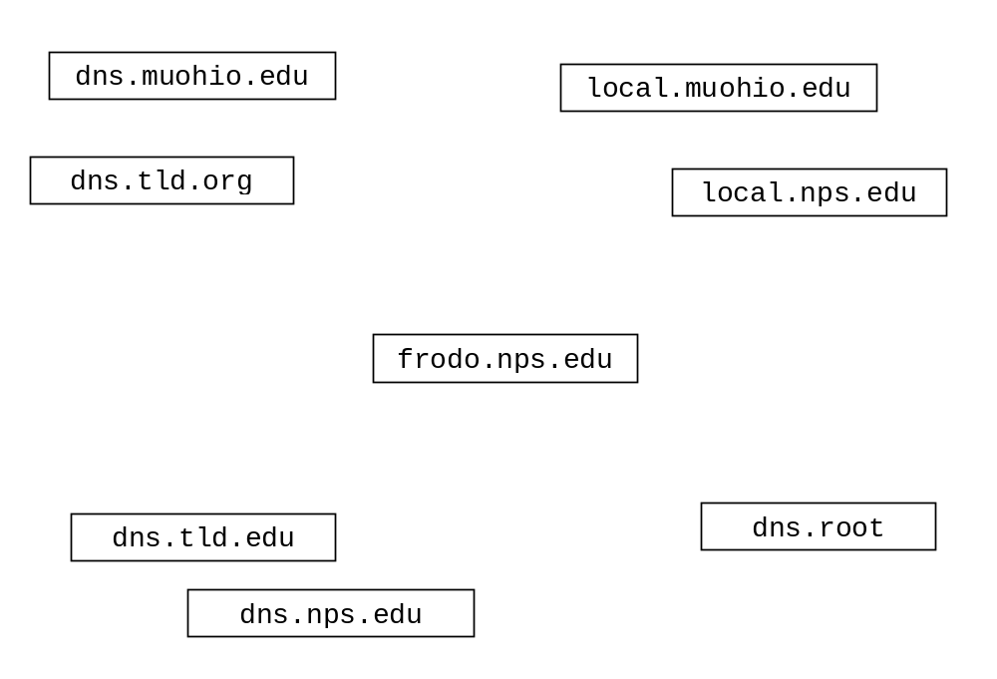

- Complete the Server class on the next page. Do not worry about handling exceptions. Allow the main method to throw them to the OS. (40 points)

- Clients send groups of three doubles using TCP.
- If all numbers received are positive, the Server calculates the sum of the set of three and sends the sum back to the client that sent them as a double. The server keeps the connection with the client open in order to receive another set of three numbers.
- If the Server receives a negative number from a client, it will immediately close the connection with the client without sending back a sum and start waiting for a connection from another client.
- The Serves handles clients sequentially (no multi-threading).
- After serving ten clients, the server closes down.
- The Server listens on port number 7777.
- Close all open streams and sockets before the program exits.

import java.io.*;
import java.net.*;

public class TCPSumServer {

public static void main(String[] args) throws Exception
{

